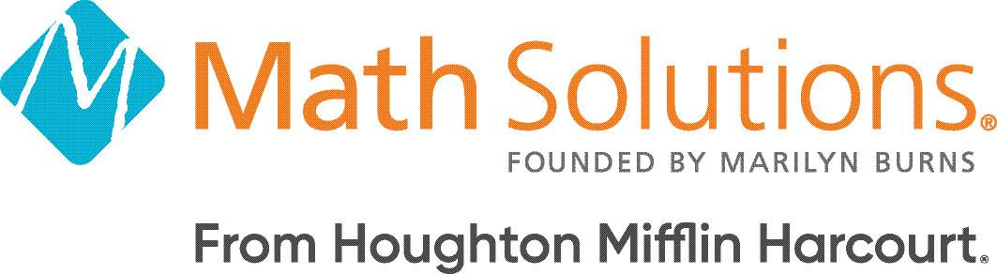

Getting Started with Into AGA® 2020 Course Agenda
OVERVIEW
This course develops participants’ understanding of the research-based pedagogy and instructional strategies used throughout Into AGA 2020 that contribute to increased conﬁdence, competence, and achievement in mathematics.

Participants explore the unique program components, engaging learning experiences, and built-in support as they begin their journey with Into AGA.

LEARNING OUTCOMES

- Enrich daily instruction by applying knowledge of Into AGA organization and pedagogy.
- Support differentiation, assessment, and effective instruction using Into AGA resources and instructional tools.
- Enhance instructional delivery and student learning using HMH technology.
This course is available as a half-day or full-day in-person course or via live webinar.

TOPICS | PURPOSE OF THE SESSION
Setting the Stage | Build community and learn about the agenda and experiences of the day.
INTRODUCING  Into AGA 2020 | Get to know Into AGA, including an overview of the design, introduction to growth mindset, and preview of the components.
Student Experience | Experience Into AGA from your students' perspectives as you look at the materials they will use and the learning path they'll follow to achieve success.
Teaching and Planning | Discover the instructional flow of a unit, module, and lesson, and explore the tools and resources you'll use to plan, teach and monitor progress.
Assessment | Examine the Into AGA assessments and reports, and determine how you'll use data to drive effective instruction.
First Steps for Success | Use tools like the Getting Started Road map to guide and support you as you plan your first lessons using Into AGA.
Closing | Reﬂect on the experiences of the day and the ways in which they positively impact classroom instruction.

